Remote Desktop connection:

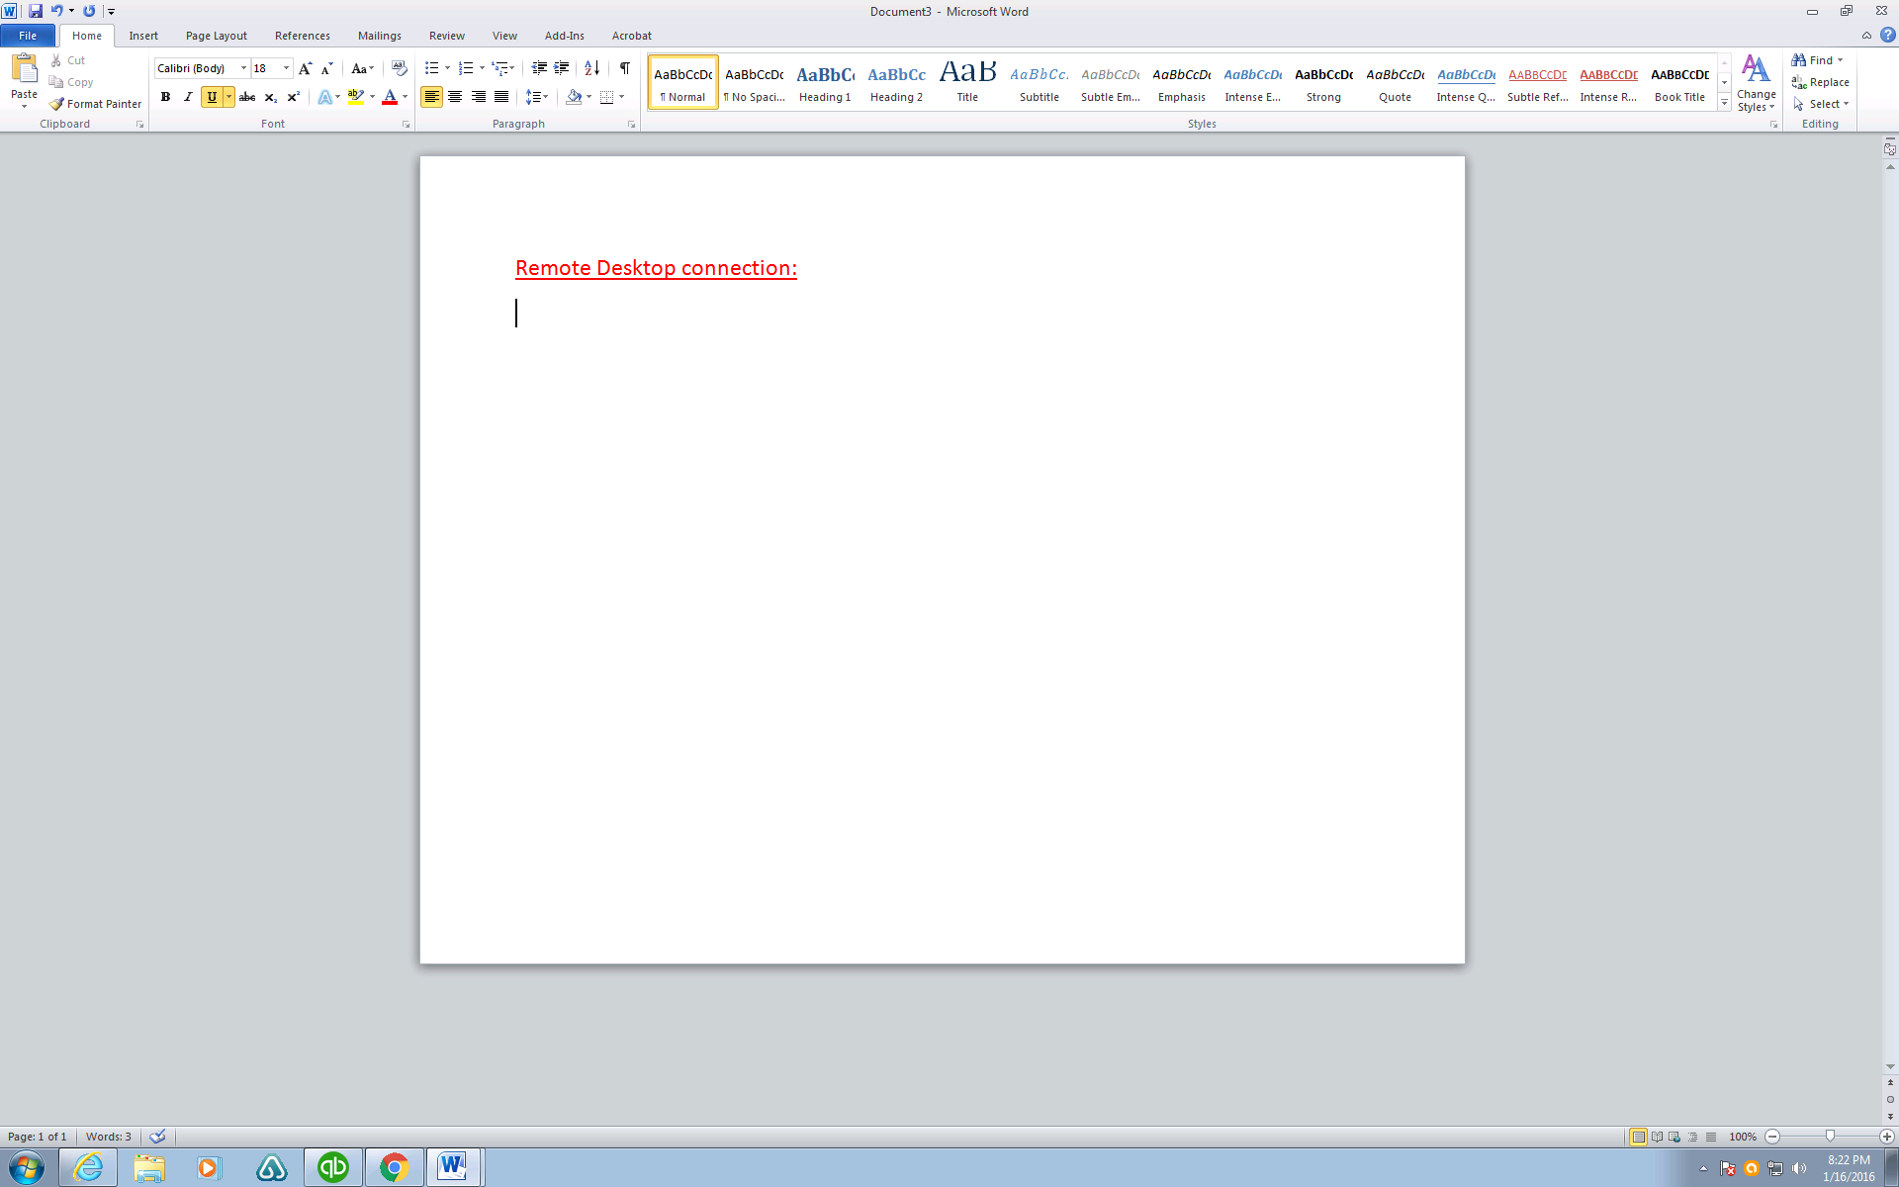

Click on this icon

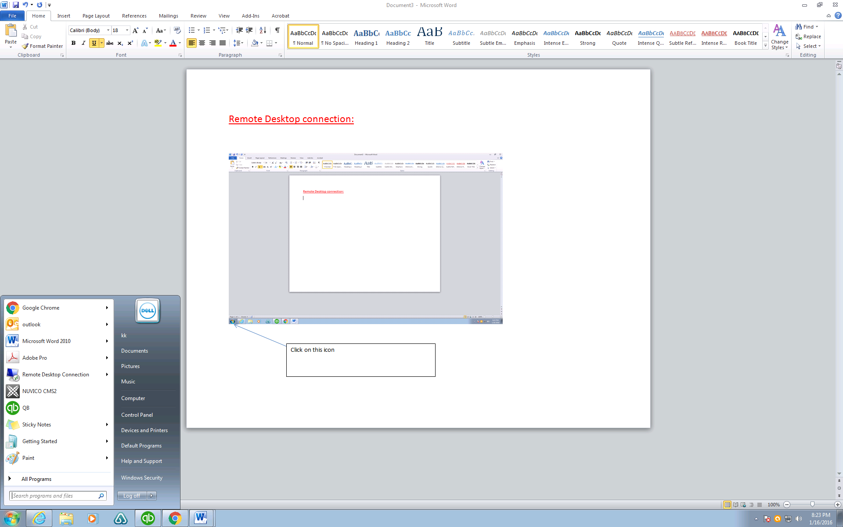

Enter:

mstsc

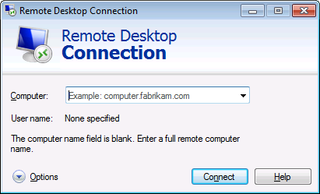

Enter the server ip address and port number:

If you are not sure, call kevin@ 917-6821302

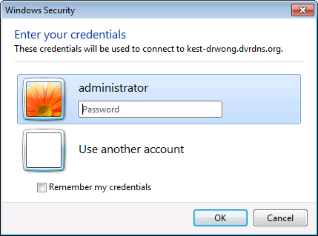

Then you will see this screen,

Enter the server login user name and password