**How to change the IP address:**

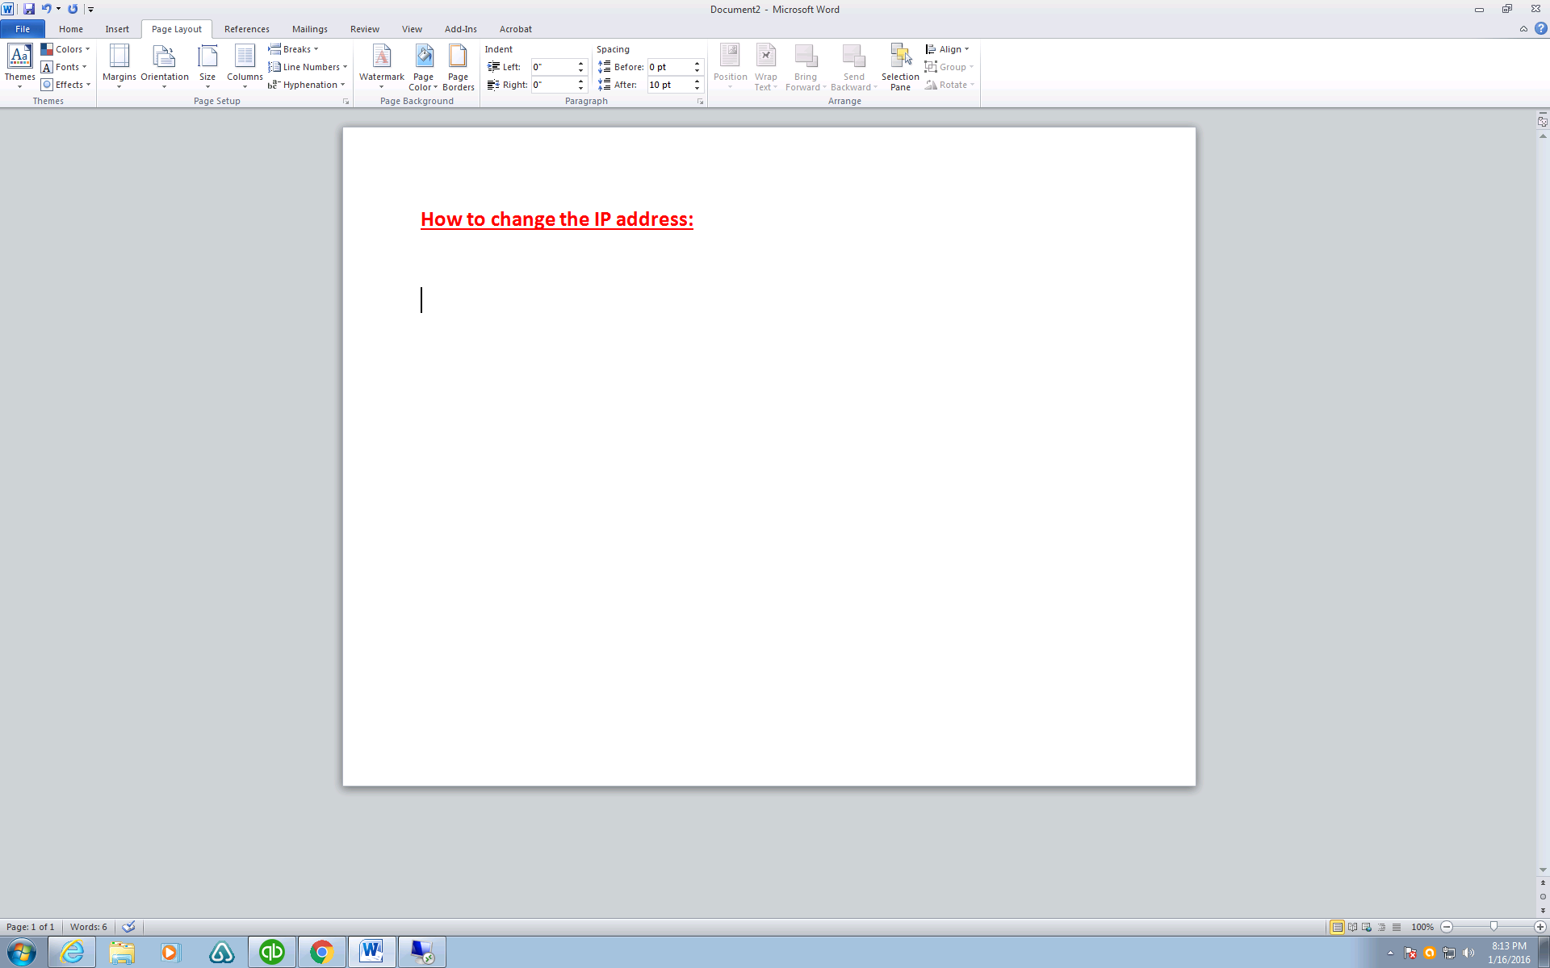

**If you do not find this icon, you can go to CONTROL PANEL**

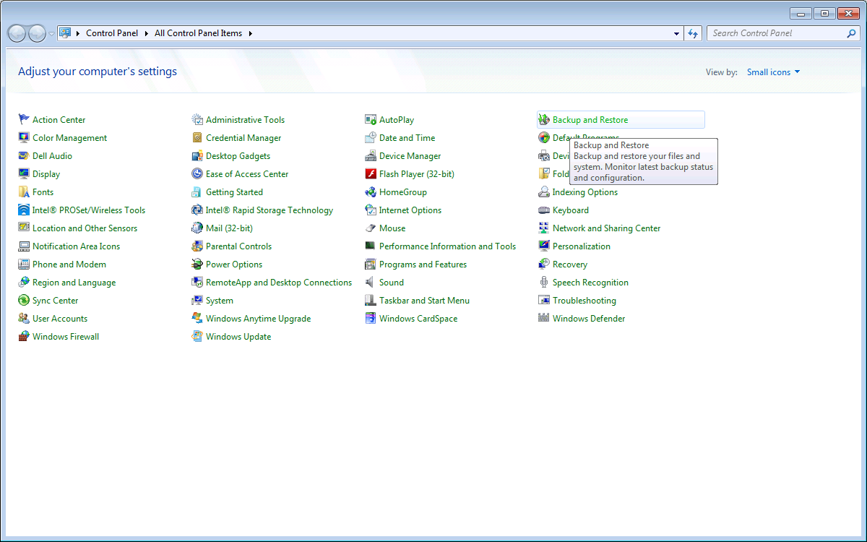

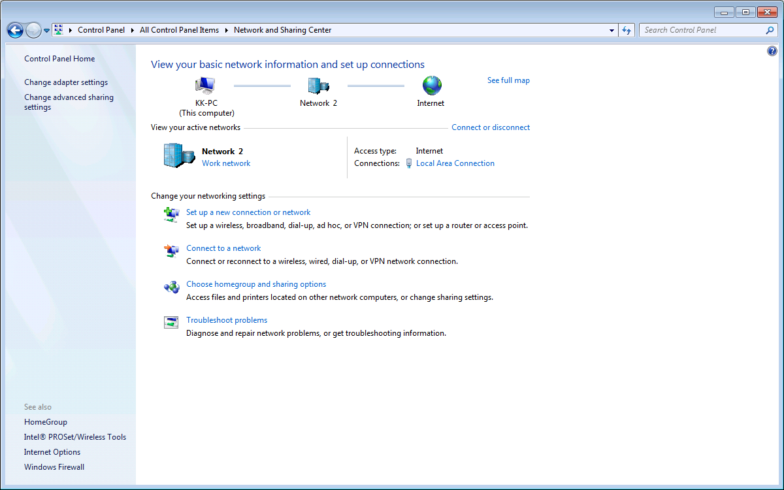

CHOOSE CHANGE ADPATER SETTING

DOUBLE CLICK

LOCAL AREA CONNECTION

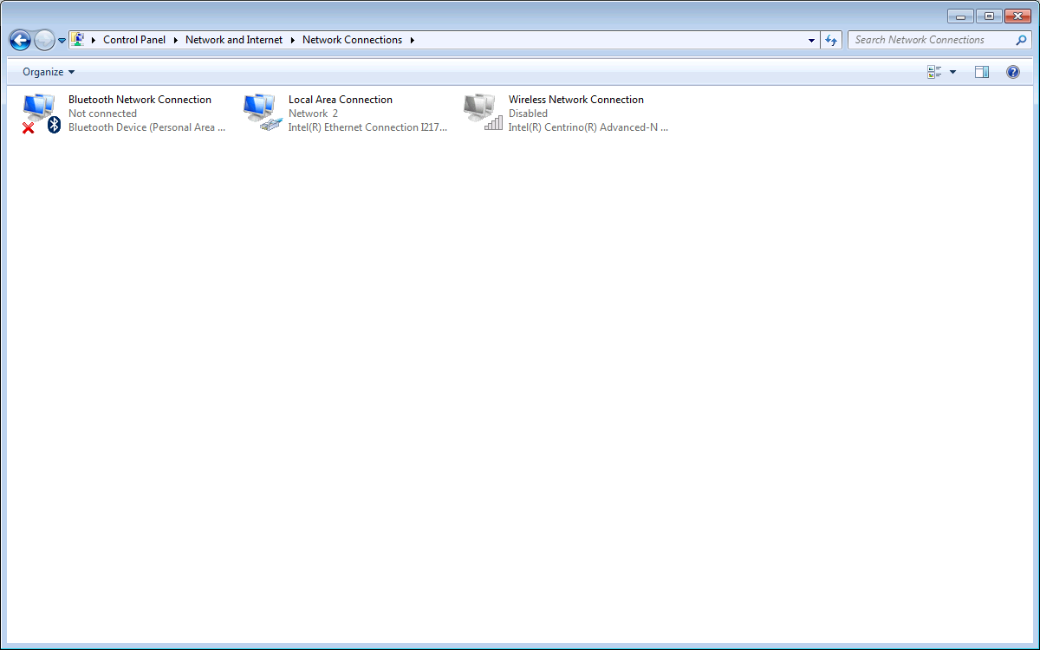

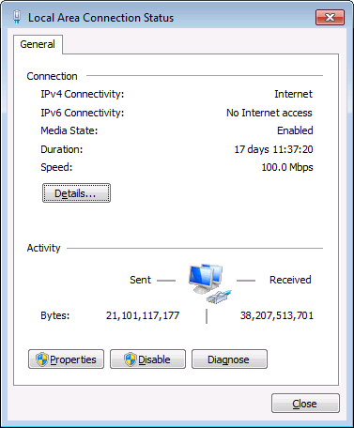

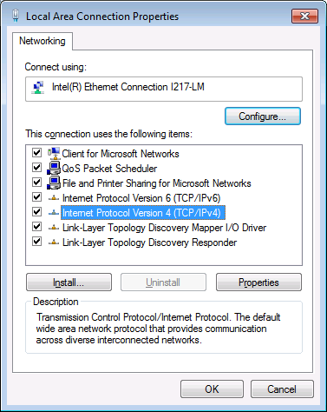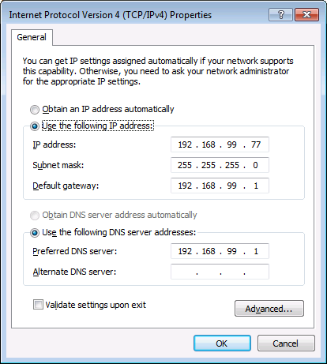

PLEASE CALL KEVIN FOR THE IP ADDRESS INFO: