Login in Sonicwall, Go to Firewall – Address Objects
Then Click on Add
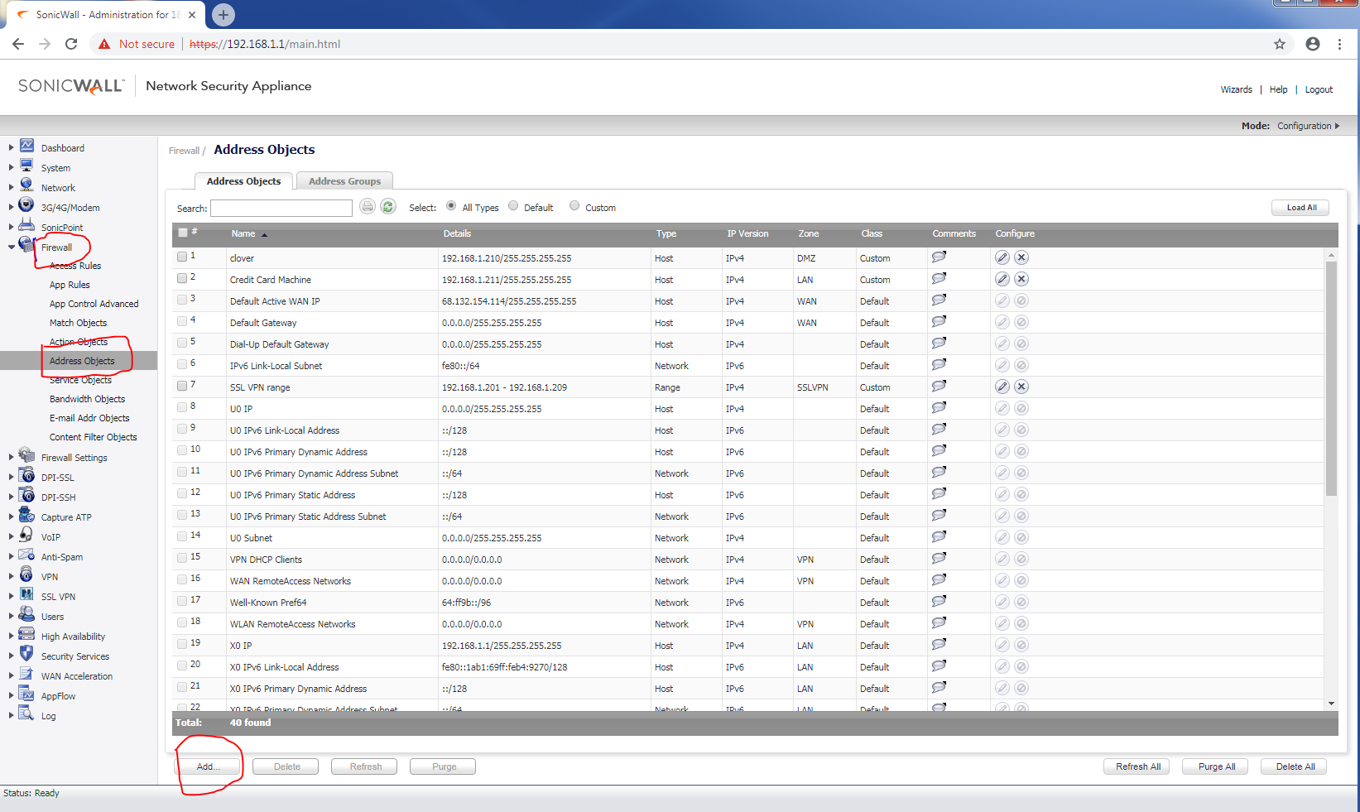

Name: Type a name for the ssl connection
Zone assignment: SSLVPN
Type: Range
Starting ip address and Ending ip address: choose an ip range for vpn connection, example: 192.168.1.210 – 192.168.1.220
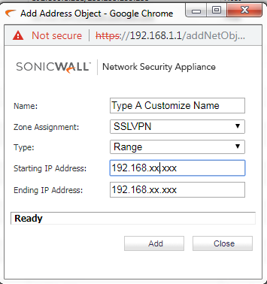

Afterward SSL VPN will show up, go to SSL VPN – server settings
Click on LAN and WAN, make sure both bubble show as green
SSL VPN Port: type a customize port number
User Domain: type a customize domain
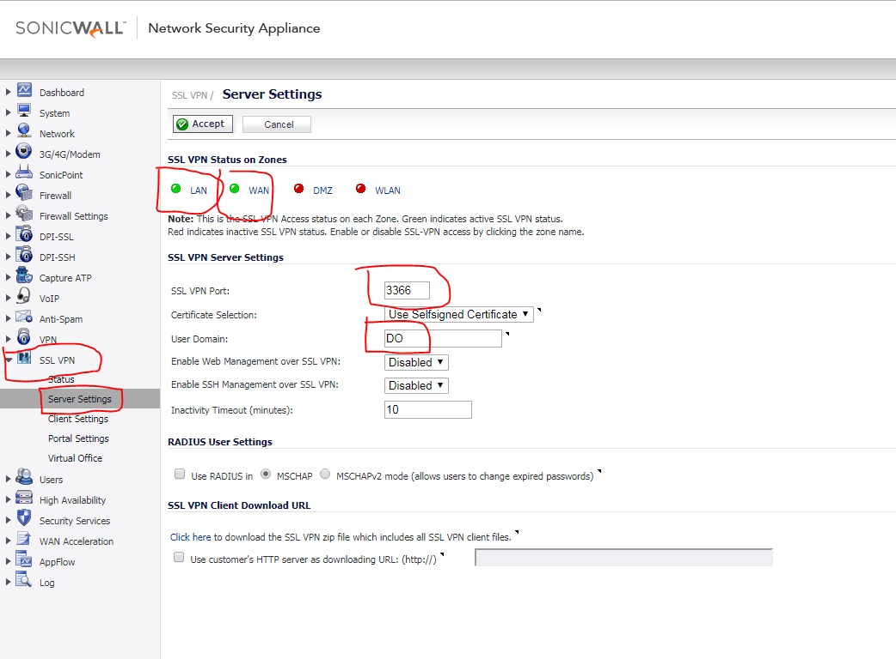

Afterward go to client settings on the same SSL VPN page, and click on the little pen for editing
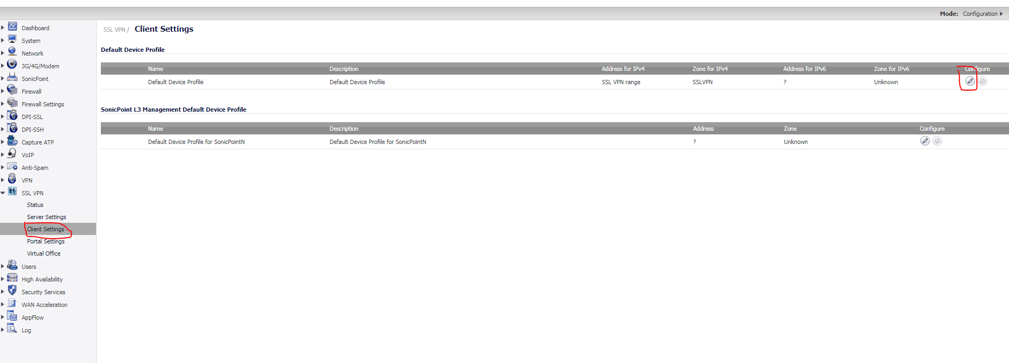

First settings tab
Zone IP V4: SSLVPN
Network address IP V4: choose the name type early for when create SSLVPN under network objects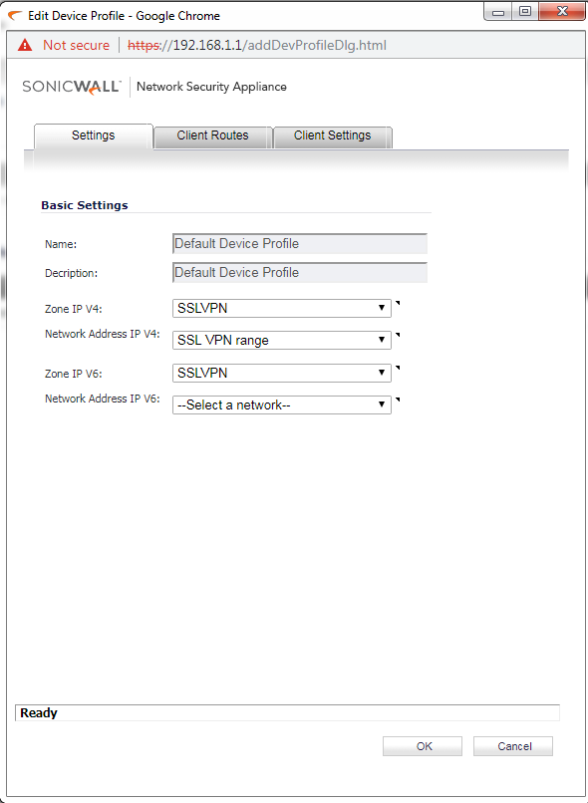
Go to Client Routes
Move X0 Subnet from Networks to Client Routes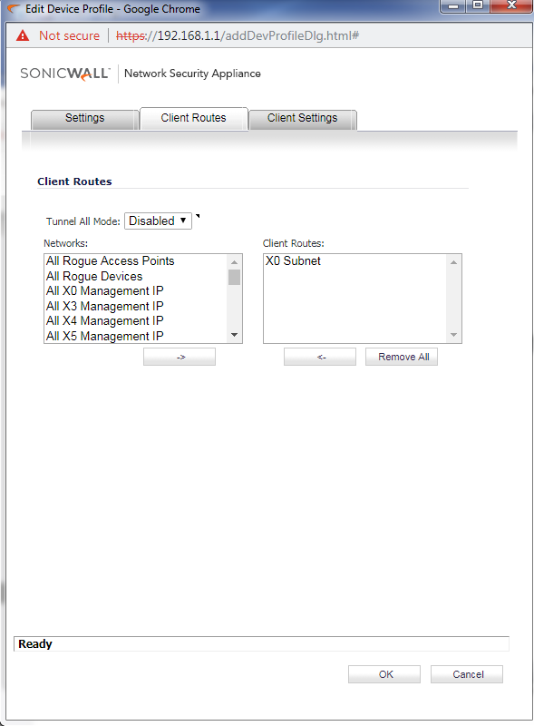
Client Settings tab
DNS Server 1: type for the office gateway
DNS server 2 : type 8.8.8.8
Enable these two:
Exit Client After Disconnect
Create Client Connection Profile
User Name & Password Caching: Allow saving of user name & password
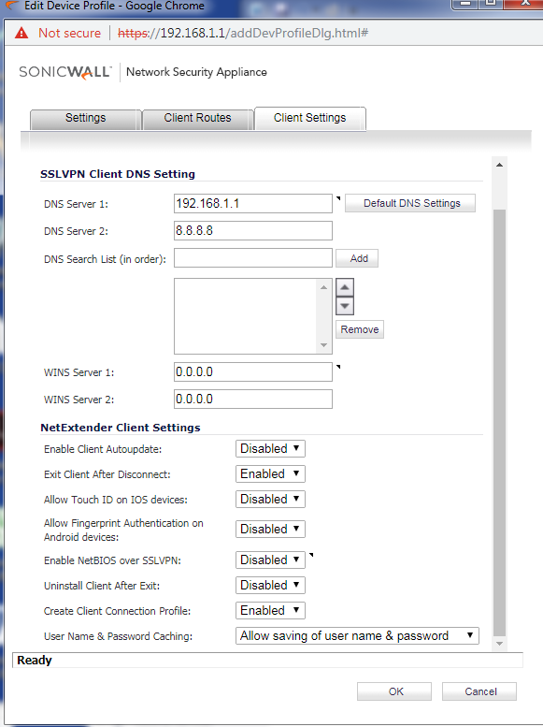

Next move on Uers – Local Users, click on Add User….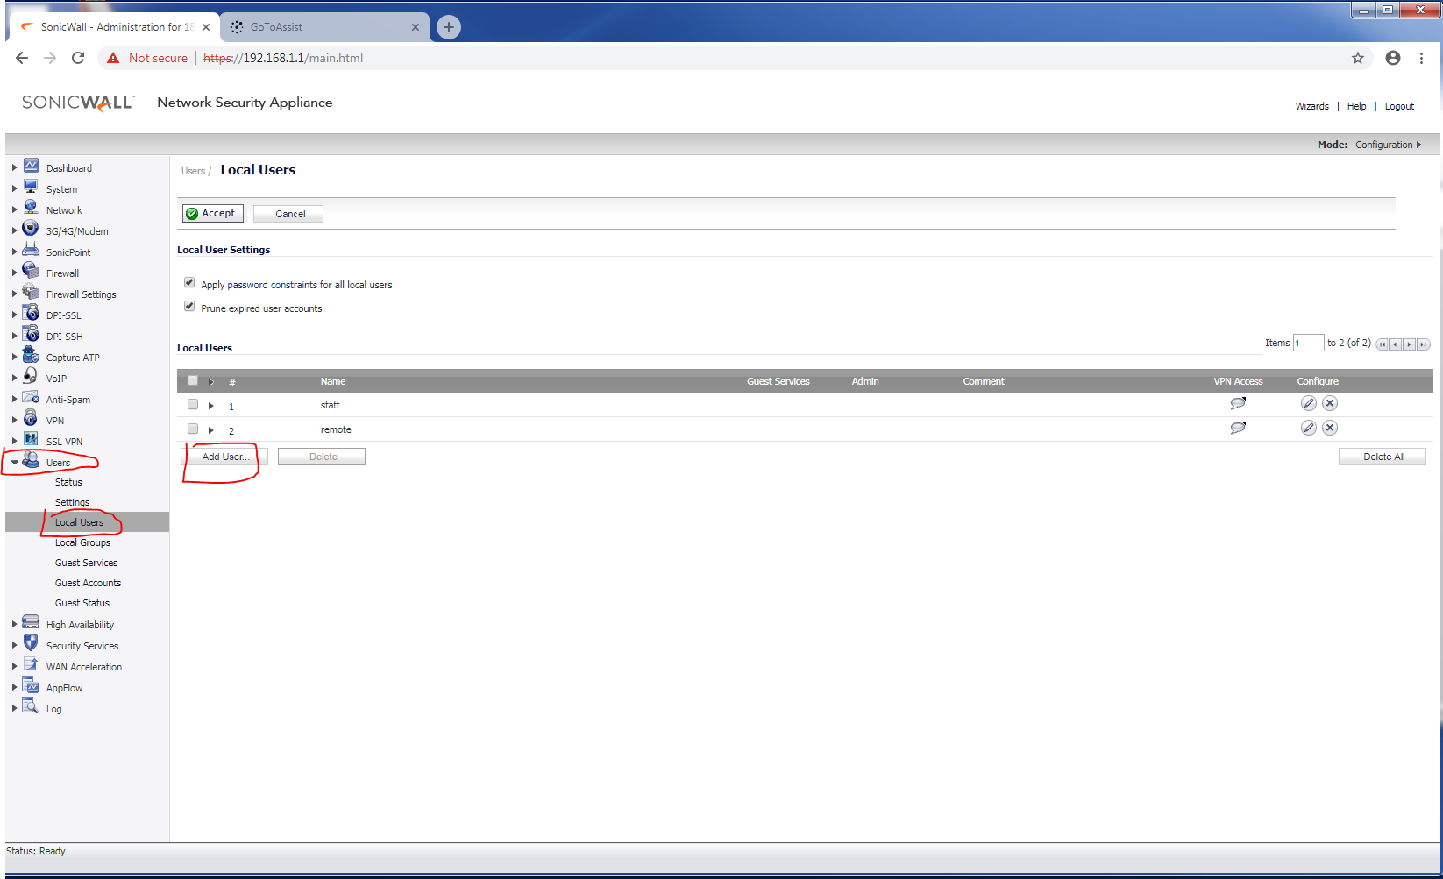

Name: type a username
Password: type a password
Confirm password: type same password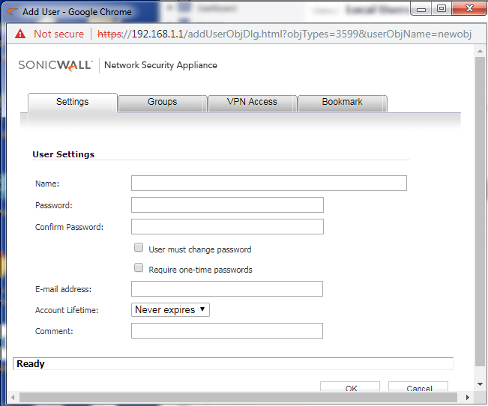

Go to Groups
Make sure Everyone, Trusted Users and SSLVPN Services are in the Member of list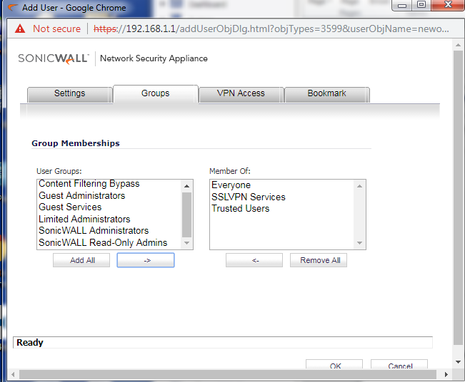

Go to VPN Access
Make sure LAN Subnets is in the Access List:
